OSI Model ,TCP/IP Model and Protocols
ToC:
OSI Model
TCP/IP Model
Protocols
Transmission Control Protocol
Port Number
OSI Model : (Universal Language for Computer Networking)
When you're trying to understand how networks work, both the OSI model and the TCP/IP model are incredibly useful, but they serve slightly different purposes.
In short: You should understand both, but rely more on the TCP/IP model for practical, real-world internet communication.
OSI Model:
*It's a conceptual and theoretical framework for how network communication should ideally be structured.
*The Open Systems interconnection (OSI) model, it provides a standard for different computer systems to be able to communicate with each other, it is created by the International Organization for Standardization.(IOS)
*The OSI Model can be seen as a universal language for computer networking. It is based on the concept of splitting up a communication system into seven abstract layers, each one stacked upon the last.
Link: https://www.cloudflare.com/learning/ddos/glossary/open-systems-interconnection-model-osi/
*Layers of OSI Model:
(To Remember: Mobile--> Application --> Presentation -->
7.Application
6.Presentation
5.Session
4.Transport
3.Network
2.Data Link
1.Physical
Advantages:
*Clarity and Granularity (the quality of including a lot of small details): Its 7 layers provide a very detailed and clear separation of functions, making it excellent for understanding principles of networking and for breaking down complex problems into smaller, manageable parts.
* Troubleshooting: When a network problem occurs, you can often pinpoint it to a specific layer (e.g., "It's a Layer 2 problem" or "This looks like a Layer 7 issue").
Disadvantages:
* Not Directly Implemented: The internet wasn't built exactly according to the OSI model. It's more of a reference or guide.
* More Complex: More layers can sometimes feel overly detailed for practical application.

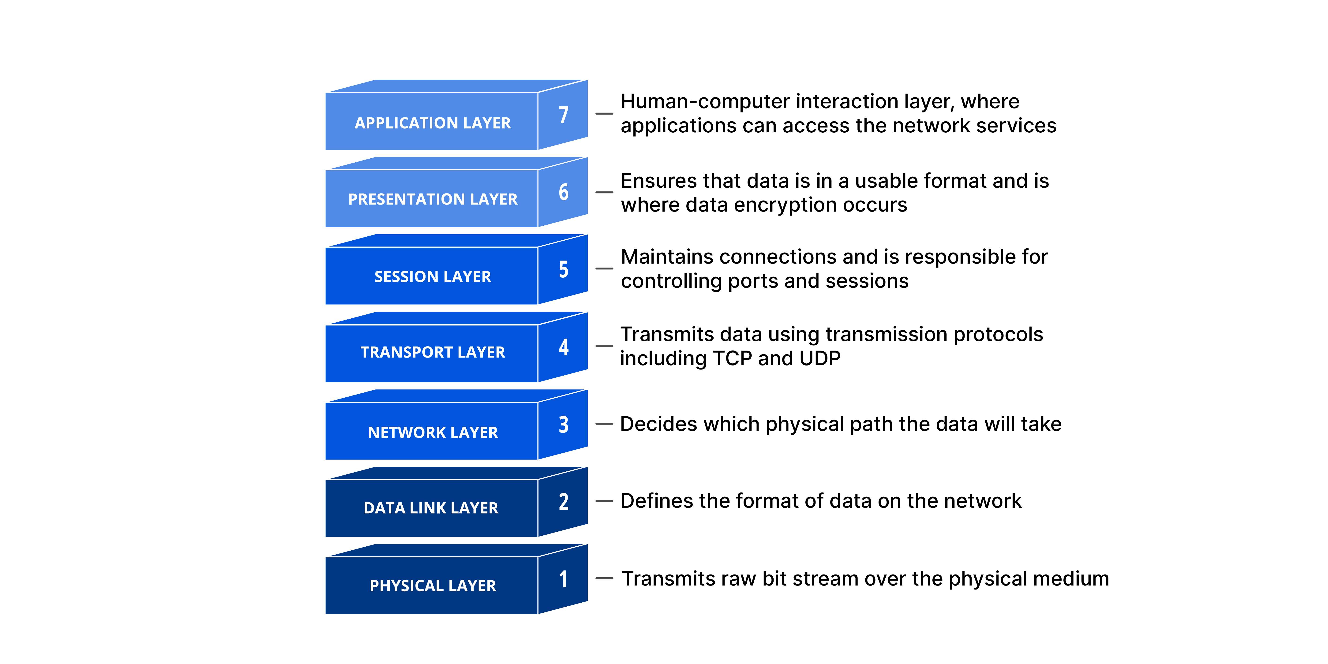
Datalink layer--> Defines the format of data on the network. (IP/MAC)
Network Layer --> Decides which physical path the data will take…(Here, Packets are forwarded from their source to the destination.)
Session Layer--> Two devices to transact (carry out) specific functions between each other a session is required.
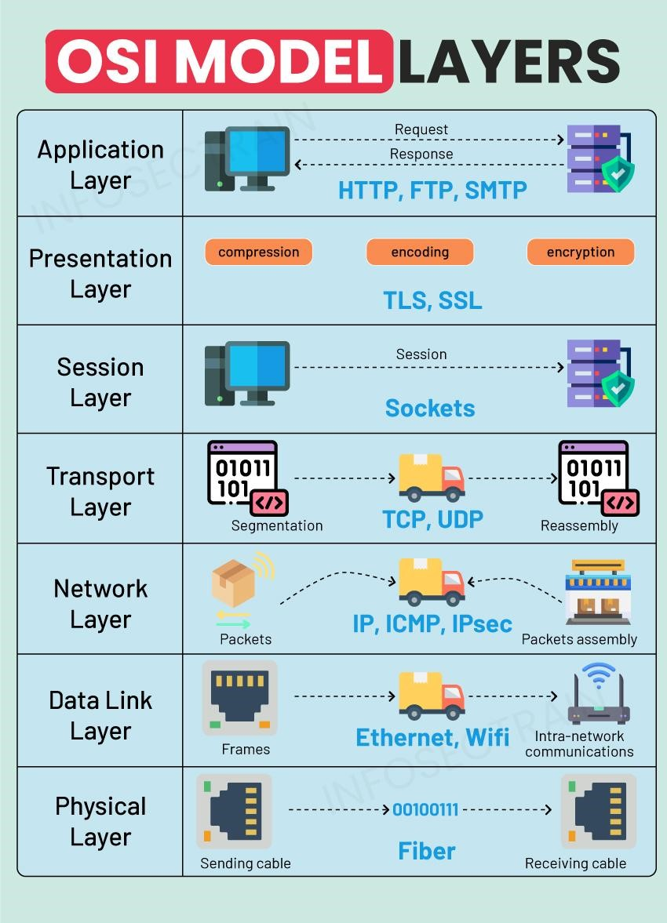
Data Link Layer: Ethernet (IEEE 802.3) and Wi-Fi (IEEE 802.11) operate at the Data Link Layer (Layer 2) to manage media access, handle physical addressing (MAC addresses), and ensure error-free data transmission by formatting data into frames for reliable delivery within a local network.
Network Layer: ICMP stands for Internet Control Message Protocol; IPsec (Internet Protocol Security).
Transport Layer: TCP and UDP are Internet protocols that transmit data in different way.
TCP (Transmission Control Protocol) is a connection-oriented, reliable protocol that guarantees ordered, error-checked data delivery, ideal for web browsing and email;
UDP (User Datagram Protocol) is a connectionless, faster, but less reliable protocol that prioritizes speed over guaranteed delivery, making it suitable for streaming and online games.

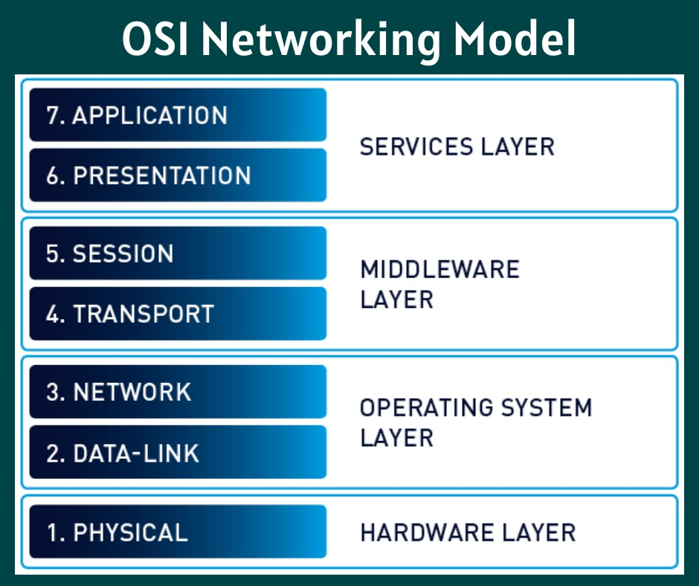
Hardware Layer --> Physical Layer (Layer 1)
Operating System Layer --> Data-Link and Network Layer (Layer 2 and Layer 3)
Middleware Layer --> Transport and Session Layer (Layer 4 and Layer 5)
Services Layer--> Presentation and Application Layer (Layer 6 and Layer 7)
TCP/IP Model:
*It's a practical and implementation-oriented model that closely matches how the internet actually works.
It's based on the set of protocols (TCP and IP being the most famous) that were developed and widely adopted for the internet.
* Layers: It typically has 4 or 5 layers (depending on how the lowest layers are grouped).
4-Layer Model:
4. Application
3. Transport
2. Internet
1. Network Access (or Link)
5-Layer Model: (Separates Network Access into Physical and Data Link, similar to OSI)
5. Application
4. Transport
3. Network (Internet)
2. Data Link
1. Physical
*For security groups, you're primarily dealing with concepts from the TCP/IP model's Transport Layer (TCP/UDP and ports) and Internet Layer (IP addresses),
as well as the Application Layer (like HTTP, SSH, FTP), which sit on top of TCP/UDP.

Advantages:
* Real-World Application: It directly maps to the protocols used on the internet today. If you're working with actual network traffic, you'll see TCP/IP headers and operations.
* Simpler: Fewer layers make it more straightforward for practical implementation and understanding.
* Widely Adopted: It's the standard for internet communication.
* Flexible: Its looser layering allows for easier integration of new technologies within existing layers.
Disadvantages:
* Less Granular: The combination of some layers means it's less detailed than the OSI model for very specific functional breakdowns. (Granular --> Level of detail or precision)
* Protocol Dependent: It's built around specific protocols, making it less "generic" than OSI. (Generic --> General)
(In general use: If you talk about a "generic brand" of cereal, it's not a specific, well-known brand like Kellogg's; it's a general, often cheaper version that's not branded.)

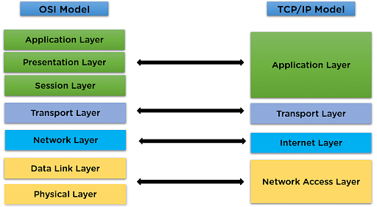
*Here's a simplified flow involving the main layers and protocols:
Scenario: Your Laptop (Source) requests a webpage from a Web Server (Destination) using HTTP/HTTPS (on TCP Port 80/443).
1. Application Layer (Your Laptop):
* Your web browser (the application) wants to get www.example.com.
* It uses the DNS protocol to ask a DNS server: "What's the IP address for www.example.com?"
* Once it gets the IP address (e.g., 203.0.113.123), the browser constructs an HTTP (or HTTPS) request: "GET /index.html HTTP/1.1".
* This HTTP request is handed down to the next layer.
2. Transport Layer (Your Laptop):
* Since HTTP needs reliable delivery, the HTTP request is handed to the TCP protocol.
* TCP breaks the HTTP request into smaller chunks called segments.
* Each segment is given a source port number (a random port on your laptop, e.g., 54321) and a destination port number (e.g., 80 for HTTP or 443 for HTTPS, because that's where the web server listens).
* TCP also adds sequence numbers to each segment to ensure they can be reassembled in the correct order at the destination.
* TCP performs a "three-way handshake" with the server's TCP layer to establish a connection.
* These TCP segments are handed down to the next layer.
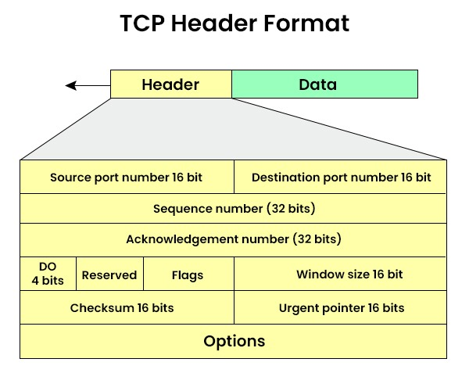
3. Internet Layer (Your Laptop):
* The TCP segments are handed to the IP protocol.
* IP wraps each TCP segment into an IP packet.
* Each IP packet is given a source IP address (your laptop's public IP) and a destination IP address (the web server's IP: 203.0.113.123).
* IP determines the next "hop" (e.g., your home router's IP) and prepares the packet for physical transmission.
* These IP packets are handed down to the next layer.
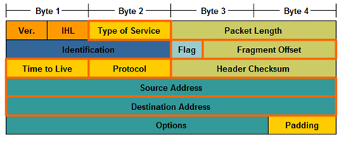

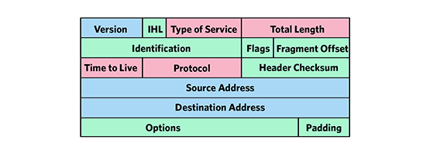

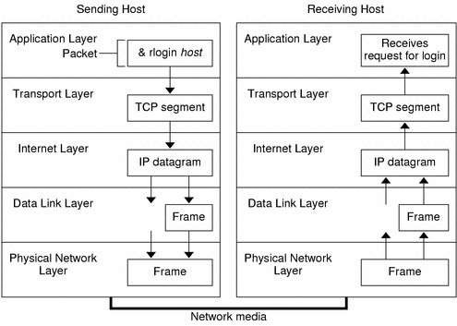

4. Network Access Layer (Your Laptop):
* The IP packets are translated into signals (electrical, light, radio waves) that can travel over your physical network medium (e.g., Wi-Fi signals, Ethernet cable).
* They are sent out onto the network.
5. Journey Through the Internet (Routers & Intermediate Devices):
* As the packets travel from your laptop, through your router, and across the internet, various routers (which operate at the Internet Layer)
examine the destination IP address in each packet.
* Routers use IP's routing rules to forward the packets closer and closer to the destination web server.
*Routing Table (RIB - Routing Information Base): This is essentially a database stored in the router's memory (RAM).
It contains a list of known network destinations and the "best" path to reach them.
*The router operates mainly at the Network Layer (Layer 3).
*In TCP/IP model, Router works at the Internet Layer.

This is the layer where IP addressing, routing, and packet forwarding happen.
Routers use IP addresses to decide where to send packets.
Protocols at this layer: IP (IPv4/IPv6), ICMP, ARP, OSPF, BGP etc.
Each router receives a frame, de-encapsulates it to get the IP packet, consults its routing table to find the next hop (Primary function) based on the destination IP, and then re-encapsulates the IP packet into a new frame for the next link.
Primary function of router is about "finding the next hop towards that destination".
Security Groups operate mainly at the Transport Layer of the TCP/IP model.
Security Groups filter traffic based on IP addresses and ports (for example: allow TCP 443, block TCP 22).
Security Groups (on the Web Server's side) and Firewalls:
* Before the packet even reaches the web server's operating system, the Security Group (acting as a virtual firewall) for the web server intercepts the incoming IP packet.
* It checks the destination IP, protocol (TCP), and destination port (80 or 443) in the packet header.
* It also checks the source IP address (your laptop's public IP).
* If there's an inbound security group rule allowing TCP traffic on port 80/443 from your source IP, the packet is allowed to proceed to the web server. If not, it's dropped.
6. Arriving at the Web Server (Destination):
* Network Access Layer (Web Server): The signals arrive at the web server's network interface card and are converted back into IP packets.
* Internet Layer (Web Server): IP examines the destination IP (its own) and hands the packets up to the Transport Layer.
* Transport Layer (Web Server):
* TCP receives the segments. It reassembles them, checks for errors, and ensures they are in the correct sequence.
* Once the full HTTP request is reassembled, TCP hands it up to the Application Layer.
* Application Layer (Web Server):
* The web server application (e.g., Apache, Nginx) receives the HTTP request from TCP.
* It processes the "GET /index.html" request, finds the index.html file.
* It then generates an HTTP response containing the webpage content.
* This HTTP response then flows back down through the layers on the server, across the internet, and back up the layers on your laptop, completing the communication cycle.
This detailed flow illustrates how different protocols and layers collaborate to enable seamless communication across the internet, with security groups acting as critical gatekeepers at the network boundaries.



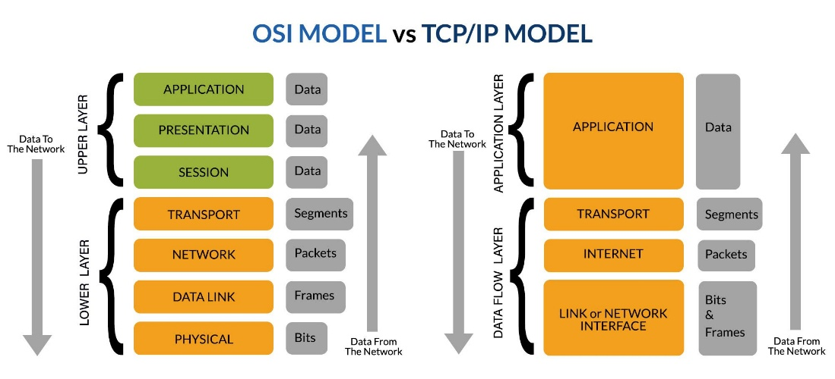

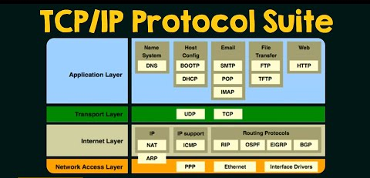
Protocols:
OSI Model Protocols:

Port numbers primarily belong to the Transport Layer (Layer 4). They allow the Transport Layer protocols (TCP and UDP) to direct data to the correct application or service running on a device.
Here's a simple, layer-wise explanation with common protocols and their typical port numbers, keeping in mind that port numbers are explicitly used at Layer 4 and above for application identification:
7. Application Layer (Closest to the user)
* Function: Provides network services directly to end-user applications. This is where users interact with network applications.
* Protocols (and their common default ports, which they use via TCP/UDP):
* HTTP: (Hypertext Transfer Protocol) - Web Browse. TCP Port 80
* HTTPS: (Hypertext Transfer Protocol Secure) - Secure web Browse. TCP Port 443
* FTP: (File Transfer Protocol) - File transfer. TCP Ports 20 (data) & 21 (control)
* SSH: (Secure Shell) - Secure remote access. TCP Port 22
* Telnet: (Teletype Network) - Unencrypted remote access. TCP Port 23
* SMTP: (Simple Mail Transfer Protocol) - Sending email. TCP Port 25
* DNS: (Domain Name System) - Translates domain names to IP addresses. Primarily UDP Port 53 (for queries), but also TCP Port 53 (for zone transfers).
* DHCP: (Dynamic Host Configuration Protocol) - Assigns IP addresses. UDP Ports 67 (server) & 68 (client)
* POP3: (Post Office Protocol version 3) - Retrieving email. TCP Port 110
* IMAP: (Internet Message Access Protocol) - Retrieving and managing email. TCP Port 143
* NTP: (Network Time Protocol) - Synchronizing clocks. UDP Port 123
* RDP: (Remote Desktop Protocol) - Remote desktop access. TCP Port 3389
6. Presentation Layer
* Function: Handles data formatting, encryption, decryption, and compression. It ensures data is presented in a readable format for the Application Layer.
* Protocols: No specific public "port numbers" associated directly with this layer's protocols, as they typically operate within the data stream managed by Application Layer protocols. Examples include:
* JPEG, MPEG, GIF: (Image/Video formats) - Deal with data representation.
* ASCII, EBCDIC: (Character encoding)
* SSL/TLS: (Secure Sockets Layer / Transport Layer Security) - Often works across this and the Session/Transport layers for encryption/decryption, encapsulating application data.
5. Session Layer
* Function: Establishes, manages, and terminates communication sessions between applications. It controls dialogues.
* Protocols: Similar to the Presentation Layer, no specific public "port numbers" for these protocols themselves. They manage the session using services provided by the layers below. Examples include:
* NetBIOS: (Network Basic Input/Output System)
* RPC: (Remote Procedure Call)
* PPTP: (Point-to-Point Tunneling Protocol) - Used for VPNs.
4. Transport Layer
* Function: This is the layer where port numbers are defined and used. It provides reliable (or unreliable) end-to-end data delivery between specific applications using these port numbers for "service-point addressing." It handles segmentation, reassembly, flow control, and error control.
* Protocols (which use port numbers):
* TCP: (Transmission Control Protocol) - Connection-oriented, reliable.
* UDP: (User Datagram Protocol) - Connectionless, unreliable.
* (Note: The specific port numbers like 80, 443, 21, etc., are used by TCP or UDP to identify the application running on that port.)
3. Network Layer
* Function: Handles logical addressing (IP addresses) and routing of data packets across different networks. It determines the best path for data.
* Protocols: No concept of "port numbers" at this layer. Instead, it uses IP addresses for device identification.
* IP: (Internet Protocol) - The core protocol for routing packets (IPv4, IPv6).
* ICMP: (Internet Control Message Protocol) - Used for network diagnostics (e.g., ping).
* ARP: (Address Resolution Protocol) - Maps IP addresses to MAC addresses (operates between Layer 2 and 3).
* Routing Protocols (e.g., OSPF, BGP): Determine paths.
2. Data Link Layer
* Function: Provides node-to-node data transfer within a single network segment. It handles physical addressing (MAC addresses).
* Protocols: No concept of "port numbers." Instead, it uses MAC addresses for local device identification.
* Ethernet: Most common wired LAN technology.
* Wi-Fi (IEEE 802.11): Wireless LAN technology.
* PPP: (Point-to-Point Protocol)
1. Physical Layer (Closest to the physical medium)
* Function: Deals with the physical transmission of raw bit streams over a physical medium (cables, radio waves).
* Protocols/Standards: No concept of "port numbers" or logical addresses. Deals with voltage levels, cable types, connectors, radio frequencies, etc.
* Cables: (Ethernet cables, fiber optics)
* Connectors: (RJ-45)
* Wireless signals: (Radio frequencies)
Key Takeaway: Port numbers are an essential part of the Transport Layer (Layer 4), allowing the protocols at that layer (TCP and UDP) to identify which Application Layer (Layer 7) service or process on a specific device should receive the incoming data.

Transmission Control Protocol (TCP):
Transmission Control Protocol (TCP) is a core Internet protocol that provides reliable, ordered, and error-checked delivery of data streams between applications communicating over an IP network, ensuring data arrives completely and in the correct sequence.

User Datagram Protocol (UDP) is a connectionless transport layer protocol that provides a fast, but unreliable, "best-effort" delivery of data packets without establishing a prior connection or guaranteeing delivery order.

Most of the protocols use TCP and UDP?
It's accurate to say that most widely used application-layer protocols rely on TCP rather than UDP for their transport.
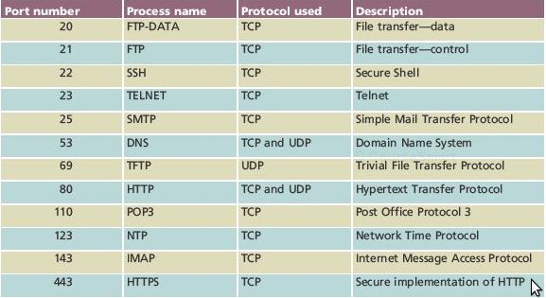
TCP Segment Structure: A single TCP segment can carry both outgoing data AND an acknowledgment for incoming data. This "piggybacking" of ACKs within data segments is a common optimization in TCP.
Piggybacking --> A technique where an acknowledgment (ACK) for received data is attached to an outgoing data packet, rather than sending a separate, dedicated ACK packet.
Sliding Window Technique:
The sliding window technique is a flow control method that allows a sender to transmit multiple data packets (within a defined "window" size) without waiting for an acknowledgment for each individual packet, thereby increasing network efficiency and throughput.
Three way Handshake:
* No application data is sent in the SYN or SYN-ACK packets. These are purely for control and synchronization.
* The connection is fully established after the third ACK.
* The client can send data in the third ACK packet, but it's not guaranteed or the primary function. The server usually cannot send data until it receives this final ACK from the client, with the exception of TCP Fast Open, which is a more advanced (and less common) feature.
* Most significant data transfer happens after the 3-way handshake is complete.
So, to directly answer your statement: "In 3 way handshake, client side data will send to server and again data will send to client side".
* Client side data will send to server: Potentially, a small amount of initial data can be sent by the client in the third ACK packet.
*And again data will send to client side: True, but this would generally happen after the handshake is complete, as the server needs to receive the client's final ACK to confirm its readiness to receive data and then respond with its own data.

What is x+1 and y+1 in 3 way handshake?

In the TCP 3-way handshake, 'x' and 'y' represent initial sequence numbers (ISNs) chosen randomly by the client and server, respectively.
The '+1' signifies the acknowledgment of one byte of "control data" (the SYN packet itself) and the expectation of the next sequence number in the stream.
(Control Data --> Information that dictates how a system or process should behave or operate.)
Here's a breakdown of how x+1 and y+1 are used:
Step 1: Client sends SYN
* Client to Server: Sends a SYN packet with Sequence Number = x (client's Initial Sequence Number).
* x is a randomly chosen sequence number by the client.

Step 2: Server sends SYN-ACK
* Server to Client: Upon receiving the client's SYN, the server responds with a SYN-ACK packet.
* Sequence Number = y (server's Initial Sequence Number, also a randomly chosen number).
* Acknowledgment Number = x + 1: This is the server's acknowledgment of the client's SYN packet. It indicates that the server successfully received the client's SYN with sequence number x and is now expecting the next byte of data from the client to start with sequence number x+1.

Step 3: Client sends ACK
* Client to Server: Upon receiving the server's SYN-ACK, the client responds with an ACK packet.
* Sequence Number = x + 1: The client now uses its own sequence number that was acknowledged by the server (its original x plus one).
* Acknowledgment Number = y + 1: This is the client's acknowledgment of the server's SYN packet. It indicates that the client successfully received the server's SYN with sequence number y and is now expecting the next byte of data from the server to start with sequence number y+1.

After these three steps, both the client and server have acknowledged each other's initial sequence numbers and have agreed on the starting point for their respective data streams. The connection is now established, and data transfer can begin, with each side using x+1 and y+1 (and subsequent increments based on data sent) as their active sequence numbers.

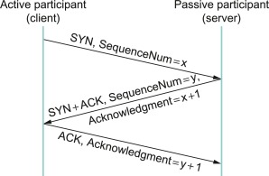

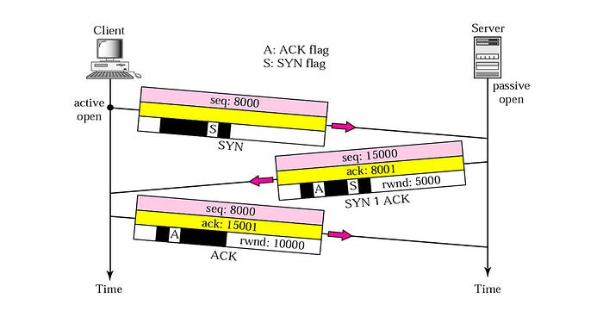

TCP Closing Connection:
The TCP connection termination process is almost always a four-way handshake. This is due to the full-duplex nature of TCP, where each side of the connection can send and receive data independently.
Half-Duplex Communication:
In a half-duplex system, data can be transmitted in both directions, but not simultaneously. It's like a one-lane road where traffic can go both ways, but only one direction at a time.

Full-Duplex Communication:
In a full-duplex system, data can be transmitted in both directions simultaneously. It's like a two-lane highway where traffic can flow freely in both directions at the same time.

Here's a quick recap of the four steps:
* Client sends FIN (FIN_WAIT_1 State): By initiating the close, the client sends a FIN segment, signaling that it has no more data to send.
* Server acknowledges FIN (CLOSE_WAIT State): The server acknowledges the FIN from the client and enters the CLOSE_WAIT state. In this state, the server knows the client won't send any more data, but the server can still send data to the client if it has any remaining. At this point, the connection is "half-closed" – the server only can still send data to the sender.
* Server sends FIN (LAST_ACK State): Once the server has finished sending any remaining data, it also sends its own FIN segment to the client, indicating that it, too, has no more data to send.
* Client acknowledges Server's FIN (TIME_WAIT State): The client acknowledges the FIN from the receiver and sends back its final ACK segment to acknowledge the server's FIN. Then immediately, the client then enters the TIME_WAIT state. It waits for 2 * MSL (Maximum Segment Lifetime).
Upon receiving the final ACK, the server (which was in the LAST_ACK state) transitions directly to the CLOSED state. Its resources for that connection are fully released. After this, both sides can close their respective ends of the connection.
*Maximum Segment Lifetime (MSL) --> Fundamental concept in TCP that defines the maximum amount of time a TCP segment is expected to exist or "live" within the internetwork system. 🕰️
*TTL--> TTL (Time To Live) is a numerical value in an IP packet header that decrements by one at each router hop, causing the packet to be discarded if it reaches zero, primarily to prevent infinite network loops.
Flow:Imagine a letter being sent through a mail system.
TTL (Time To Live) is like a "hop limit" or "maximum journey count" written on that letter.
Every time the letter passes through a new sorting office (a router on the internet), this number is reduced by one.
If the number reaches zero before the letter gets to its destination, the sorting office throws the letter away.
This prevents letters from endlessly circulating the mail system if there's a mistake in the address or routing, which would otherwise clog up the entire system.
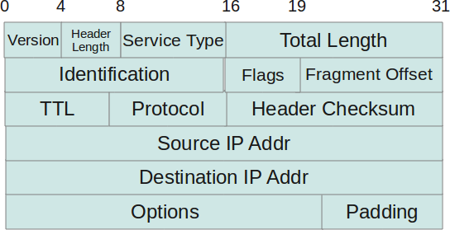

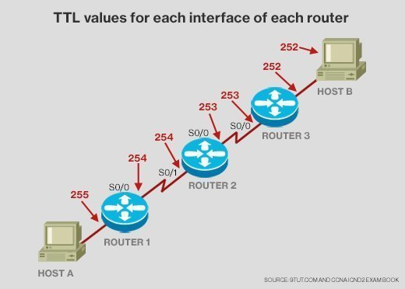

TCP's reliability during connection termination: what happens if the final ACK is lost?
Let's clarify the scenario and the outcome:
1. If the final ACK from client to server reaches the server:
* Client's Action: The client, after sending the final ACK, immediately enters the TIME_WAIT state. It waits for 2 * MSL (Maximum Segment Lifetime).
* Server's Action: Upon receiving the final ACK, the server (which was in the LAST_ACK state) transitions directly to the CLOSED state. Its resources for that connection are fully released.
* Connection Status: Both sides consider the connection fully closed after the TIME_WAIT period on the client side expires.

2. If the final ACK from client to server is lost:
This is where TCP's robust error handling comes into play.
* Client's Action: The client has sent the final ACK and immediately entered TIME_WAIT. It is now silently waiting for 2 * MSL. It does not know if its ACK was lost initially.
* Server's Action: The server, in the LAST_ACK state, is expecting that final ACK from the client side. Since it doesn't receive it within a certain timeout period,
it assumes its FIN segment (the one it sent in step 3 of the four-way handshake) was not acknowledged.
* Server Retransmits FIN: Because TCP guarantees reliable delivery, the server will retransmit its FIN segment to the client.
* Client in TIME_WAIT Receives Retransmitted FIN: When the client, which is in the TIME_WAIT state, receives this retransmitted FIN, it knows what to do: it will re-send its final ACK. It does not initiate a new connection or try to send data. It simply ensures the other side gets the acknowledgment for its FIN.
* Server Receives Retransmitted ACK: The server eventually receives this retransmitted ACK, confirms that its FIN has been acknowledged, and then transitions to the CLOSED state.
* Client's TIME_WAIT Continues: The client's TIME_WAIT timer resets or continues, ensuring the 2 * MSL duration is met, after which it also fully closes.

Key Takeaway: The TIME_WAIT state is precisely designed to handle the loss of the final ACK.
Without TIME_WAIT, if the final ACK was lost and the client immediately closed, the server would be stuck in LAST_ACK retransmitting its FIN indefinitely (or until its retransmission timers expired and it forcibly reset the connection, which is not a graceful shutdown). The TIME_WAIT state allows the client to provide the necessary re-acknowledgment for the server's FIN, ensuring a clean and graceful shutdown on both ends, even in the face of packet loss.
Optimized Three-Way Handshake (Less Common for Termination)
In some cases, if the server has no more data to send immediately after receiving the client's FIN, it can combine its ACK to the client's FIN with its own FIN. This would look like:
* Client sends FIN.
* Server sends FIN + ACK (acknowledging client's FIN and sending its own FIN).
* Client sends final ACK.
This effectively makes it a three-way termination. However, the full four-way handshake is the most common and robust approach.
What happens to resources?
During this process, the operating system gradually releases the resources associated with the TCP connection, such as:
* Socket buffers
* Port numbers
* Entry in the connection table
This ensures a clean shutdown and frees up resources for new connections.

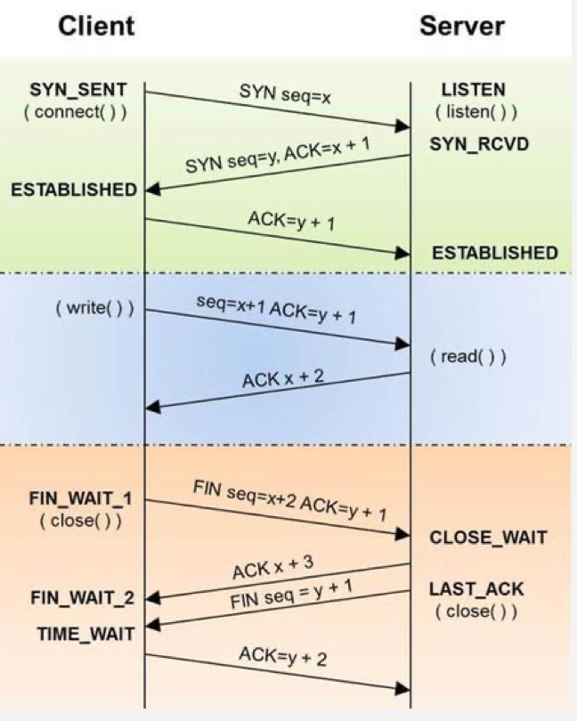

In summary:
* The 3-way handshake is for connection establishment, not primary data transfer.
* While a client initiates a connection and often an initial request, the established TCP connection is full-duplex, allowing both client and server to send and receive data.
* The server is indeed responsible for routing its response packets back to the client.
How it is possible to send data simultaneously either one of the side will be sender and the other would be acceptor?

You've hit upon a key concept in network communication: Full-Duplex communication. But TCP is designed to enable both sides to send and receive data simultaneously on the same connection.

Let's break down how this is possible, addressing the idea that one side must be a sender and the other an acceptor:
Two independent data streams for sending and receiving:
Within a single TCP connection, there will be two independent data streams:
* One stream from Client to Server: The client has its own sequence numbers for the data it sends, and the server acknowledges that data.
* One stream from Server to Client: The server has its own sequence numbers for the data it sends, and the client acknowledges that data.
Both the client and the server are continuously acting as both senders and receivers, managing their own outgoing data streams and acknowledging the incoming data streams from the other party. This is the essence of TCP's full-duplex capability.
Buffering at Both Ends:
Both the client and the server maintain send and receive buffers.
* When an application wants to send data, it writes it to its TCP send buffer. TCP then segments this data and sends it over the network.
* When data arrives from the network, TCP places it into its receive buffer. The application then reads data from this receive buffer.
These buffers allow for asynchronous operation. The application doesn't have to wait for the network to be free to send data; it can simply write to its buffer. Similarly, incoming data can be buffered even if the application isn't immediately ready to process it.
Synchronous operations execute sequentially, blocking further execution until completion, while asynchronous operations run independently in the background, allowing other tasks to proceed concurrently.
Hardware Support (Full-Duplex Ethernet):
At the physical layer, modern Ethernet networks are predominantly full-duplex. This means that the network interface cards (NICs) at both ends of a connection can truly transmit and receive electrical signals on the same cable at the same time. Older technologies like hub-based Ethernet were half-duplex (meaning only one device could send at a time), but switched Ethernet allows for simultaneous transmission and reception.

Port number:
* IP Address: Identifies a specific device (like a server, computer, or phone) on a network. It's like the street address of a building.
* Port Number: Identifies a specific application or service within that device. It's like the apartment number or specific office within that building.
Socket Address --> A socket address is the combination of an IP address and a port number, uniquely identifying an endpoint for communication on a network.
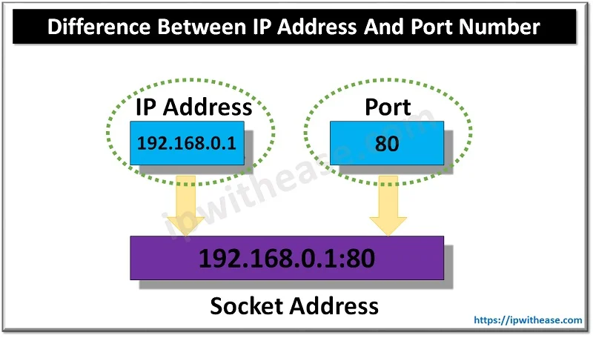

Why are port numbers needed?
Imagine a server that hosts a website, provides email services, and also runs a database. All these services are on the same server, meaning they share the same IP address. When a packet arrives at that server's IP address, how does the server know if the packet is for the website, the email service, or the database?
This is where port numbers come in. Each service "listens" on a specific port number:
* A web server typically listens on port 80 (for HTTP) or 443 (for HTTPS).
* An email server might listen on port 25 (for SMTP) or 110 (for POP3).
* A database server might use its own specific port, like 3306 for MySQL.
When a client wants to communicate with a specific service, it sends its request to the server's IP address and the port number associated with that service. The server then uses the port number to direct the incoming packet to the correct application.

Key characteristics of port numbers:
* 16-bit unsigned integers: This means they range from 0 to 65535. (Port numbers are Host numbers? No, port numbers are not host numbers.)
* Associated with a transport protocol: Port numbers are primarily used by transport layer protocols like TCP (Transmission Control Protocol) and UDP (User Datagram Protocol).
* Categories: Port numbers are broadly categorized:
* Well-Known Ports (0-1023): These are reserved for common services and are assigned by the Internet Assigned Numbers Authority (IANA).
Examples:
* 20/21: FTP (File Transfer Protocol)
* 22: SSH (Secure Shell)
* 23: Telnet
* 25: SMTP (Simple Mail Transfer Protocol)
* 53: DNS (Domain Name System)
* 80: HTTP (Hypertext Transfer Protocol)
* 110: POP3 (Post Office Protocol version 3)
* 143: IMAP (Internet Message Access Protocol)
* 443: HTTPS (HTTP Secure)
* Registered Ports (1024-49151): These are also assigned by IANA but for specific applications and services, often proprietary ones.
(Proprietary --> Proprietary means something is owned and controlled exclusively by a private individual or company.)
* Dynamic/Private/Ephemeral Ports (49152-65535): These are used by client applications when they initiate a connection.
The operating system dynamically assigns these ports for outgoing connections, and they are typically released after the communication ends.
In summary: Port numbers are essential for network traffic to be correctly routed to its intended destination application.
All protocols needs to be installed in all layers?
It's a common misconception that "all protocols need to be installed in all layers" of a network model.
Protocols are fundamentally sets of rules and standards. They are like the grammar and vocabulary of network communication.
How they are implemented:
* Built into the Operating System (OS): The core networking protocols like TCP, IP, UDP, ICMP, ARP, etc., are built directly into the operating system's kernel. This is a fundamental part of how your computer can even connect to a network.
* When you install Windows, macOS, Linux, or any other OS, the TCP/IP suite and other essential network protocols are part of that installation. You don't "install TCP/IP" separately.
* These protocols are implemented in low-level programming languages (like C) and are highly optimized for performance.
* Built into Network Hardware: At the very lowest layers of the OSI model (Physical and Data Link), some protocols are implemented directly in hardware.
* For example, Ethernet protocols are embedded in your network interface card (NIC). The physical process of sending and receiving electrical signals or light pulses is handled by hardware that adheres to these protocols.
* Routers and switches also have network protocols (like routing protocols, spanning tree protocol, etc.) implemented in their firmware (which is specialized software built into the hardware).
* Implemented in Applications/Libraries: Higher-level protocols, those closer to the application layer, are often implemented as part of the application software itself or in libraries that applications use.
* HTTP (Hypertext Transfer Protocol): Your web browser (like Chrome, Firefox) implements HTTP to communicate with web servers. You don't install HTTP; it's part of your browser's code.
* FTP (File Transfer Protocol): An FTP client application implements the FTP protocol.
* DNS (Domain Name System): While the DNS client (resolver) is often part of the OS, DNS server software is an application you might install on a server.
What you do configure (not install):
Instead of "installing" protocols, you configure them. This involves setting parameters that the already-present protocols use:
* IP Address: You configure an IP address, subnet mask, and default gateway for your network interface. This tells the IP protocol how to identify your device and route traffic.
* DNS Servers: You configure the IP addresses of DNS servers that your system's DNS resolver protocol will use.
* Firewall Rules: You configure firewall rules that dictate which types of traffic (based on protocol, port, IP address) are allowed or blocked.
* Application Settings: Within applications, you might configure settings related to the protocols they use (e.g., proxy settings for HTTP, SMTP server addresses for email clients).
In essence:
* Core, lower-layer protocols: Are bundled with your operating system and network hardware.
* Higher-layer, application-specific protocols: Are built into the software applications you use or the libraries they rely on.
So, you don't download and install a "TCP protocol driver" separately. Your computer already has that fundamental capability built-in to its very core.
Here's why:
1) Layered Architecture: Network models like OSI (7 layers) and TCP/IP (4-5 layers) are designed with a layered approach.
Each layer has specific responsibilities and communicates with the layers directly above and below it.
2) Specialization: Protocols are specialized for the functions of their respective layers.

* Application Layer: Deals with specific network applications and services (e.g., HTTP, FTP, SMTP, DNS).
* Transport Layer: Provides end-to-end communication and ensures reliable data transfer (e.g., TCP, UDP).
* Network Layer: Responsible for logical addressing and routing of data packets across different networks (e.g., IP, ICMP).
* Data Link Layer: Handles error detection and correction, and defines how data is transmitted over a physical link (e.g., MAC addresses, ARP, PPP).
* Physical Layer: Deals with the physical transmission of data (e.g., Ethernet cables, Wi-Fi signals). Protocols here relate to voltage levels, timing, etc. (e.g., IEEE 802.3).
3) Efficiency: Installing every protocol on every layer would be incredibly inefficient, consuming excessive resources (memory, processing power) and creating unnecessary complexity.
4) Modularity: The layered approach promotes modularity. If a protocol at one layer needs to be updated or replaced, it generally doesn't affect protocols at other layers, as long as the interfaces between layers remain consistent.
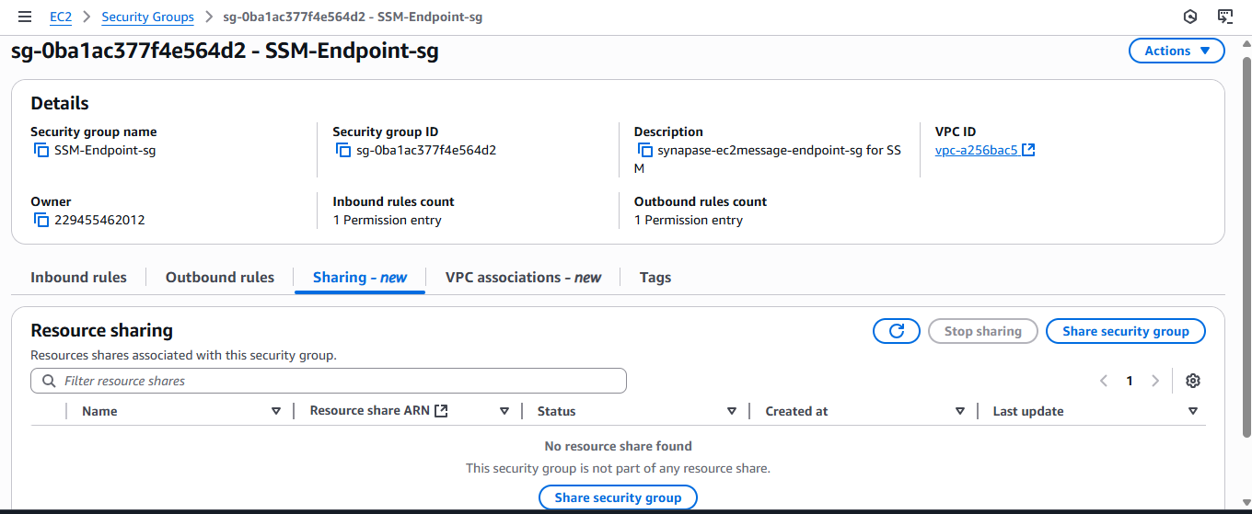

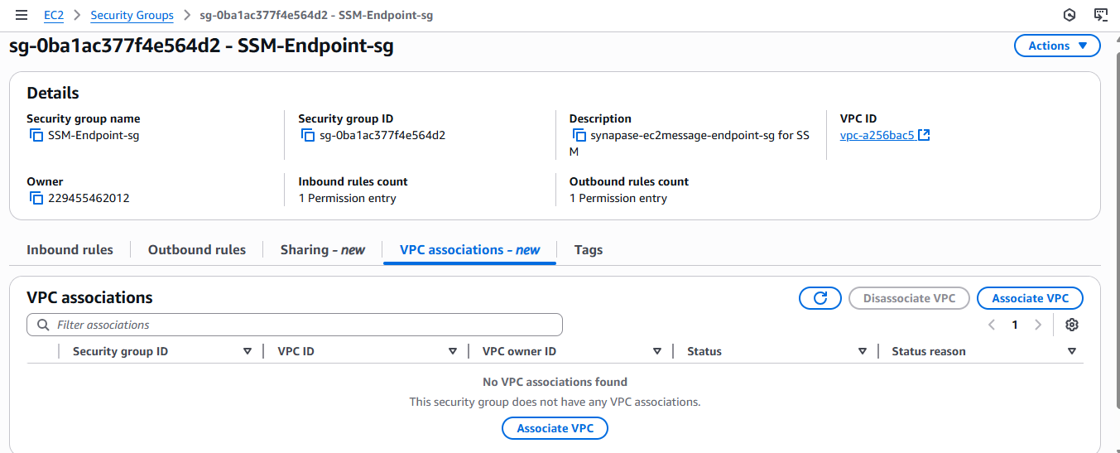

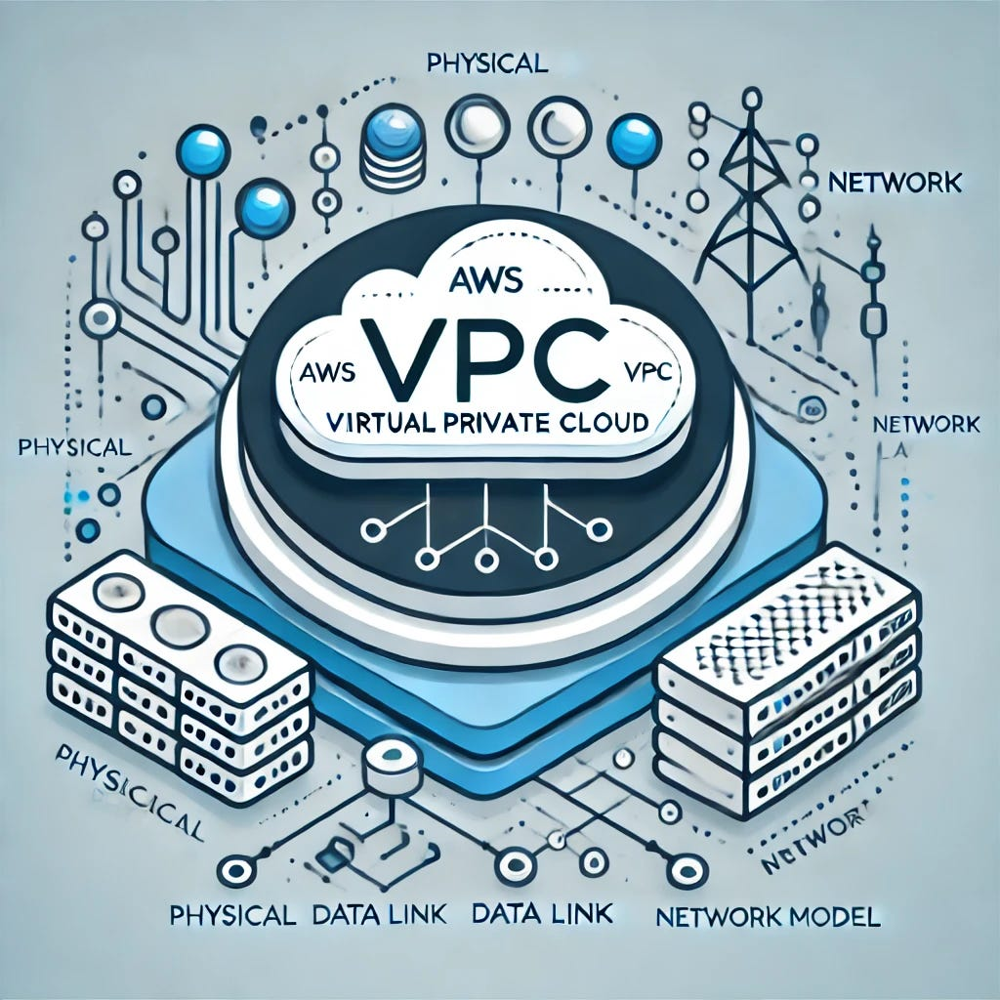
Q&A:
AWS VPC will be in which layer?
An AWS VPC (Virtual Private Cloud) operates primarily at Layer 3 (Network Layer).
(VPC--> Network Layer ; IP --> Network Layer).

If I add "SSH Protocol( Port 22)" in inbound then only I can login to the remote user?
Yes, that's correct. If you configure a security group with an inbound rule that allows SSH (port 22), it enables you to log in to the remote server.
The servers will be in application layer?
*Layer 1 (Physical): Network interface cards (NICs), cables, physical connections.
* Layer 2 (Data Link): MAC addresses, Ethernet drivers.
* Layer 3 (Network): IP addresses, routing tables within the OS.
* Layer 4 (Transport): TCP/UDP ports, handling of segments.
* Layer 5 (Session): Session management by the OS and applications.
* Layer 6 (Presentation): Data formatting, encryption/decryption (e.g., SSL/TLS certificates).
* Layer 7 (Application): This is where the actual server applications reside and provide their services.
Security group present in which layer?

Security groups, often found in cloud environments (like AWS, Azure, GCP), act as virtual firewalls. They operate primarily at the Network Layer (Layer 3) and Transport Layer (Layer 4) of the OSI model.
Here's why:
* Network Layer (Layer 3): Security groups filter traffic based on IP addresses (source and destination), which is a key function of the Network Layer.
They control what IP traffic is allowed in and out.
* Transport Layer (Layer 4): They also filter traffic based on ports and protocols (like TCP, UDP), which are functions of the Transport Layer.
This allows you to specify which applications or services can communicate.
Some advanced security group features, or more generally, next-generation firewalls, can also inspect traffic at the Application Layer (Layer 7) for deeper packet inspection and control over specific application protocols. However, the fundamental role of a security group is rooted in Layer 3 and Layer 4 filtering.

If the Security group in the server side does not allows "HTTP request" then the data will explicitly denied before into move into the physical layer of the server side?

No, that's not quite right.
Let's break down why, focusing on the order of operations in network communication and security.

* The HTTP request originates at the client (your browser). It forms the request, sends it down its own TCP/IP stack, and it eventually gets put onto the physical network.
* The request travels across the network (internet, routers, etc.). This involves many physical and data link layer transmissions, but the content of the request (the HTTP part) isn't being explicitly processed for allowance at these lower layers by the server's security group.
* The request arrives at the server's network interface (Physical Layer). The server's network card receives the electrical signals (or light pulses for fiber).
* The data moves up the server's TCP/IP stack.
* Data Link Layer: The server's network card processes the frames.
* Network Layer: The server's operating system checks the IP address to see if it's for this server.
* Transport Layer: The server's operating system checks the TCP port (e.g., port 80 for HTTP).
* This is where the Security Group comes in. A security group (common in cloud environments like AWS) or a firewall at the server's network boundary operates primarily at the Network Layer and Transport Layer (L3/L4 of the OSI model, or Internet/Transport layers of TCP/IP).
* Before the data can reach the application that would handle the HTTP request, the security group/firewall inspects the incoming packet.
* If the security group is configured to explicitly deny HTTP requests (meaning it blocks traffic on port 80 for HTTP or port 443 for HTTPS), then the packet will be dropped at this stage. It will not be allowed to proceed further up the server's TCP/IP stack to the application layer where the web server software (like Apache or Nginx) would process the HTTP request.
In summary:
The data arrives at the server's physical layer, and then starts moving up the stack. However, the security group/firewall acts as a gatekeeper at the network/transport layers (L3/L4). If the HTTP request is not allowed, the packet is dropped before it ever reaches the application layer of the server (where the web server software resides) and definitely before the web server even "sees" or tries to interpret the HTTP content of the request.
It's not "denied before moving into the physical layer of the server side" because it has to hit the physical layer to enter the server's network interface in the first place. The denial happens after the physical layer, as the data attempts to move up the server's network stack past the security controls.
Why need of 2 security groups as we can add all inbound and outbound rules over there in one line?
While you can technically add all inbound and outbound rules to a single security group, it's generally not a recommended best practice for several important reasons:
Principle of Least Privilege:
* Fine-grained control: By having multiple security groups, you can apply the principle of least privilege more effectively. Each security group can be tailored to the specific needs of a particular application tier, service, or set of instances.
* Reduced attack surface: If all your instances share one massive security group, any compromise of that group could expose your entire infrastructure. With multiple, specialized groups, a breach in one group limits the damage to only the resources associated with that group.

Organization and Management:
* Clarity and readability: A single security group with hundreds of rules becomes a management nightmare. It's hard to understand, debug, and ensure the correct permissions are in place.
* Role-based access: You can create security groups that represent specific roles (e.g., "Web Servers," "Database Servers," "Admin Workstations"). This makes it intuitive to apply security policies to instances based on their function.
* Simplified updates: If you need to update a rule for a specific type of instance (e.g., allow a new port for all web servers), you only need to modify one security group, not sift through a giant list to find relevant rules.

Reusability and Scalability:
* Templates for instances: You can create reusable security groups for common patterns. For example, a "Public Web Access" security group can be applied to all your front-end web servers, and a "Database Access" security group can be applied to all your database instances.
* Easy scaling: When you spin up new instances, you simply associate them with the appropriate pre-defined security groups, rather than having to manually add rules for each new instance to a single, large group.

Security Group Chaining (Referencing Other Security Groups):
* Many cloud providers allow you to reference other security groups in your rules. This is incredibly powerful. For example, your "Database Servers" security group can be configured to only accept traffic from the "Application Servers" security group. This means that even if the IP addresses of your application servers change, the database security group's rule remains valid because it's tied to the logical group, not specific IPs. This creates a highly dynamic and secure network.

Troubleshooting:
* When an instance can't connect, having separate security groups makes it much easier to pinpoint which specific rule in which group is blocking the traffic. A single, large group would be extremely time-consuming to troubleshoot.
Example Scenario for Multiple Security Groups:
Consider a typical 3-tier web application:
Web Tier: Instances that serve web content (e.g., Apache, Nginx).
* Security Group: sg-web-public
* Inbound: Allow HTTP (80) and HTTPS (443) from 0.0.0.0/0 (internet).
* Outbound: Allow traffic to sg-app-servers on specific ports.
Application Tier: Instances that run your application logic (e.g., Tomcat, Node.js).
* Security Group: sg-app-servers
* Inbound: Allow traffic from sg-web-public on specific application ports (e.g., 8080).
* Outbound: Allow traffic to sg-db-servers on the database port.
Database Tier: Instances running your database (e.g., MySQL, PostgreSQL).
* Security Group: sg-db-servers
* Inbound: Allow traffic from sg-app-servers on the database port (e.g., 3306).
* Outbound: (Often minimal, e.g., to monitoring services).
Each instance would then be associated with its respective security group. This design is clean, secure, and scalable.
In summary, while technically possible to use one security group, it severely hampers(causing issues) manageability, scalability, and security posture in any
non-trivial (Complex) environment. Using multiple, specialized security groups aligned with your application architecture is a fundamental best practice for cloud network security.
ICMP?(Error Reporting Protocol)

ICMP stands for Internet Control Message Protocol. It's a fundamental supporting protocol within the Internet Protocol Suite (TCP/IP), operating at the network layer (Layer 3 of the OSI model).
Unlike protocols like TCP or UDP, ICMP isn't designed to carry application data directly. Instead, its primary purpose is to:
* Send error messages: When something goes wrong with the delivery of an IP packet (e.g., destination unreachable, host down, packet too large), network devices (like routers) use ICMP to inform the original sender about the problem.
* Provide operational information: ICMP also provides diagnostic and control messages to help manage and troubleshoot network connectivity.
Key characteristics and uses of ICMP:
Error Reporting: This is ICMP's most well-known function. If an IP packet can't reach its destination for various reasons (network issues, host offline, administrative filtering), an ICMP "Destination Unreachable" message might be sent back to the source.
Network Diagnostics:
* Ping (Packet Internet Groper): This widely used utility relies on ICMP "Echo Request" and "Echo Reply" messages to check connectivity and measure round-trip time to a remote host.
* Traceroute (or Tracert): This tool uses ICMP "Time Exceeded" messages to map the path a packet takes across a network, identifying each router (hop) along the way.
Network Management: ICMP can also be used for:
* Redirect messages: A router might send an ICMP Redirect message to a host, informing it of a more efficient path to a particular destination.
* Router Advertisement/Solicitation: Used for router discovery, allowing hosts to find routers on their local network.
* Time Exceeded: Sent when a packet's "Time to Live" (TTL) expires, indicating a potential routing loop or a packet taking too long to reach its destination.
* Parameter Problem: Indicates an error in the IP header of a packet.
Important Note: ICMP is a connectionless protocol, meaning it does not establish a connection (like TCP) before sending messages. This makes it efficient for its diagnostic and error-reporting functions. While essential for network operation, ICMP can also be misused in denial-of-service (DoS) attacks, such as "ping floods," where an attacker overwhelms a target with a massive volume of ICMP echo requests.
And so, completely disabling ICMP can impact network troubleshooting, a balanced approach involving selective filtering, rate limiting, and robust monitoring is crucial for maintaining network security while still benefiting from ICMP's diagnostic capabilities.

Echo Request (ICMP Type 8):
* Purpose: An Echo Request message is sent by a source device (e.g., your computer) to a destination device (e.g., a website server or another computer on your network) to determine if that device is online and reachable. It's like sending a "Are you there?" signal.
* How it works: When you use the ping command, your computer sends an ICMP Echo Request packet to the specified IP address or hostname.

Echo Reply (ICMP Type 0):
* Purpose: An Echo Reply message is the response sent by a device that has successfully received an Echo Request. It's the "Yes, I'm here!" confirmation.
* How it works: If the destination device is online and able to process the Echo Request, it will generate and send an ICMP Echo Reply back to the source device.

In essence, they work together as a pair:
* A device sends an Echo Request to another device.
* If the other device is online and functioning, it sends back an Echo Reply.

Port 6379 is the default TCP port used by Redis, if the traffic arises form the mentioned VPC and allows inbound rules with port 6379.
Then the traffic can only access to Redis server?

1)Traffic arises from the mentioned VPC.
2)Allows inbound rules with port 6379.
If both of these conditions are met, then traffic originating from the specified VPC will be allowed to connect to services listening on port 6379 on the target resource. Therefore, it is highly probable that this traffic is intended to access a Redis server, and the rule enables that specific access.

However, to be precise:
* The traffic can access a Redis server: Yes, if a Redis server is running and listening on port 6379 on the destination, and the firewall/security group on the destination allows it.
* The traffic can only access a Redis server: This statement is slightly too strong if interpreted strictly as only Redis. While port 6379 is the default and well-known port for Redis, theoretically, another application could be configured to listen on port 6379. However, in a well-managed and typical environment, if you're allowing port 6379, it's virtually always for Redis.

Why they are not the same, and why the second is generally incorrect in a general sense:
While 6379 is the default port for Redis, it's not exclusively reserved by the operating system for Redis. Any application can be configured to listen on port 6379.

* It could be another database system (though they usually have their own default ports, they could be configured to use 6379).
* It could be a custom-built web server (e.g., written in Python, Node.js, Java, etc.).

In practical terms, for network security and administration:
If you see an inbound rule allowing traffic from a specific VPC on port 6379, you can be reasonably certain that the intention is to allow access to a Redis instance.
The "source" (the VPC) ensures that only trusted internal traffic can reach it, and the "destination port" (6379) specifically targets the Redis service.
I could not get whether TCP is also a protocol, HTTP is also a protocol, but how comes http is under TCP..?

Okay, this is a very common point of confusion, and it's essential to understand the concept of layers in networking.
Think of it like sending a letter through the postal service.
* You (the user) want to send a message. This is like the Application Layer.
* You write your message on a piece of paper. This is like the HTTP data (your web request, like "get me this webpage").
* You put the message into an envelope. This envelope is like the TCP header and data. TCP ensures the message reaches the right person and in the correct order. It adds information like sequence numbers and acknowledgements.
* You write the address on the envelope. This address is like the IP header, which tells the postal service (the internet routers) where to send the entire package across different cities and countries.
* You put the envelope into a mailbag. This mailbag is like the Ethernet or Wi-Fi frame, which gets the letter across the local street or building.

Here's the key: HTTP doesn't physically send data across the network by itself.
Let's break it down in terms of the TCP/IP Model, which is the most widely used networking model:
Application Layer (HTTP lives here):
* This is the layer closest to the user.
* HTTP (Hypertext Transfer Protocol) is a set of rules (a protocol) for how web browsers and web servers communicate. When you type www.example.com into your browser, your browser creates an HTTP request (e.g., "GET /index.html HTTP/1.1").
* Other protocols at this layer include FTP, SMTP, DNS, etc.
Transport Layer (TCP lives here):
* When your browser creates that HTTP request, it doesn't just throw it onto the network. It hands it down to the Transport Layer.
* TCP (Transmission Control Protocol) takes that HTTP request data and breaks it into smaller pieces called segments.
* TCP then adds its own TCP header to each segment. This header contains crucial information for reliable delivery:
* Source and Destination Port Numbers (e.g., HTTP uses port 80 for the server, and your browser uses a random high port).
* Sequence Numbers (to ensure data is reassembled in the correct order).
* Acknowledgement Numbers (to confirm receipt of data).
* Checksums (for error checking).
* TCP's job is to ensure that all these segments arrive at the destination, in the correct order, without errors, and that the server acknowledges receiving them. If a segment is lost, TCP will retransmit it.
* This is why HTTP is "under" TCP: HTTP uses TCP to reliably transport its data from the browser to the web server and vice-versa. HTTP specifies what data to send, and TCP specifies how to reliably get it there.
Internet Layer (IP lives here):
* Once TCP has segmented the HTTP data and added its header, it hands these TCP segments down to the Internet Layer.
* IP (Internet Protocol) takes each TCP segment and adds its own IP header.
This header contains:
* Source and Destination IP Addresses (e.g., your computer's IP address and the web server's IP address).
* IP's job is to route these "packets" (now called IP datagrams) across the internet from one network to another until they reach the destination IP address.
IP is connectionless and doesn't guarantee delivery, which is why TCP's reliability features are so important.
Network Access Layer (Ethernet/Wi-Fi live here):
* Finally, the IP datagrams are passed down to this layer.
* Protocols like Ethernet or Wi-Fi take the IP datagrams, add their own headers (creating "frames"), and actually convert the data into electrical signals or radio waves to be sent over the physical cable or airwaves to the next device.
Analogy Recap:
* HTTP: The content of your letter (the message you want to send).
* TCP: The envelope you put the letter in, with instructions for reliable delivery (like "confirm receipt," "send parts in order").
* IP: The address on the envelope, telling the postal service where to route the letter globally.
* Ethernet/Wi-Fi: The mail truck or airplane that physically carries the letter from one point to another.
So, when you say "HTTP is under TCP," it means that HTTP is an application-layer protocol that relies on the services of TCP at the transport layer to ensure its data is reliably delivered across the network. HTTP defines the language of the web, and TCP provides the reliable delivery service for that language.
TCP is not a protocol like http and https.
Https is a part of TCP protocol..?

Your statements contain some common misconceptions about how these protocols relate to each other. Let's clarify:
* "TCP is not a protocol like http and https."
This statement is incorrect. TCP (Transmission Control Protocol) is a protocol. The key difference is that TCP, HTTP, and HTTPS operate at different layers of the networking model.
* TCP operates at the Transport Layer. Its main job is to provide reliable, ordered, and error-checked delivery of data streams between applications running on hosts. It ensures that data packets arrive at their destination correctly and in the right order.
* HTTP (Hypertext Transfer Protocol) and HTTPS (Hypertext Transfer Protocol Secure) operate at the Application Layer. These protocols define how web browsers and web servers communicate, specifically for transferring hypertext (like web pages).
Think of it like this: TCP is the postal service that ensures your letter gets from one mailbox to another reliably. HTTP/HTTPS is the language/format of the letter itself (e.g., a formal business letter, a casual note).

* "Https is a part of tcp protocol"
This statement is also incorrect. HTTPS is not a part of the TCP protocol. Instead, HTTPS uses TCP as its underlying transport mechanism.
Here's the breakdown of how they relate:
* HTTPS is essentially HTTP with an added layer of security: SSL/TLS (Secure Sockets Layer/Transport Layer Security).
* SSL/TLS protocols run on top of TCP. They provide encryption and authentication for the data being transmitted.
* HTTP/HTTPS then run on top of SSL/TLS (when HTTPS is used) or directly on TCP (for HTTP).
So, the hierarchy is generally:
Application Layer: HTTP/HTTPS
Presentation/Session Layer (handled by SSL/TLS): Encryption and security
Transport Layer: TCP (for reliable data transfer)
Network Layer: IP (for addressing and routing)
Data Link Layer
Physical Layer
In summary:
* TCP is a fundamental transport protocol that provides reliability for many application-layer protocols.
* HTTP is an application-layer protocol for web communication.
* HTTPS is the secure version of HTTP, achieved by adding SSL/TLS encryption on top of TCP.
They are all protocols, but they serve different functions and operate at different layers of the network stack, with higher-level protocols building upon the services provided by lower-level ones.

